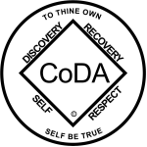

CoDA Service Conference 2020
Ad Hoc Committee Motion Structure 2

Check one: X Motion (Committee/Board)
__ VEI (See VEI Guidelines on reverse side of this form)

Committee Name: Ad-Hoc Committee
Date: 6/4/2020 Assigned Number: ____________
Revision #: 1 Revision Date: 6/25/2020

Motion Name: Chart of current legal and organizational structure to be added to FSM Part 5.

Motion/Issue: That the revised chart of the legal and operational structure of CoDA as shown here be placed in part 5 of the FSM.
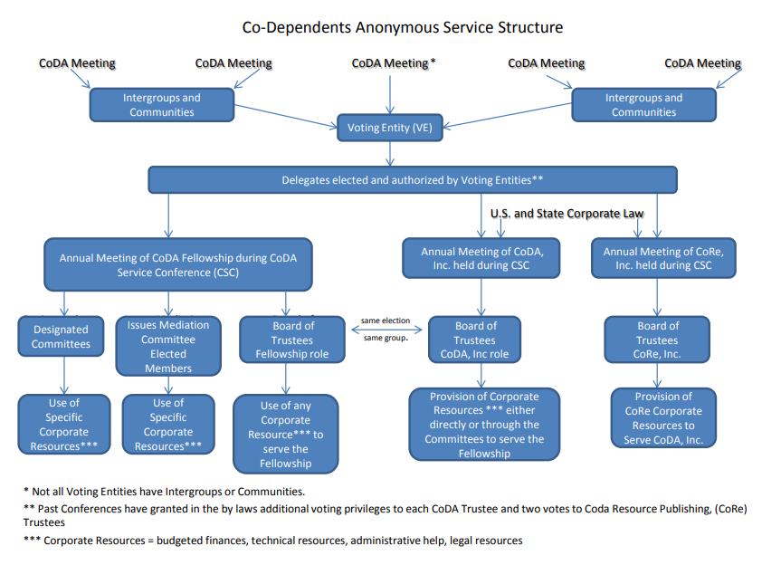
That the explanations surrounding the current chart in Part 1 of the FSM be retained in a separate page associated with this chart proposed for placement in Part 5 of the FSM.

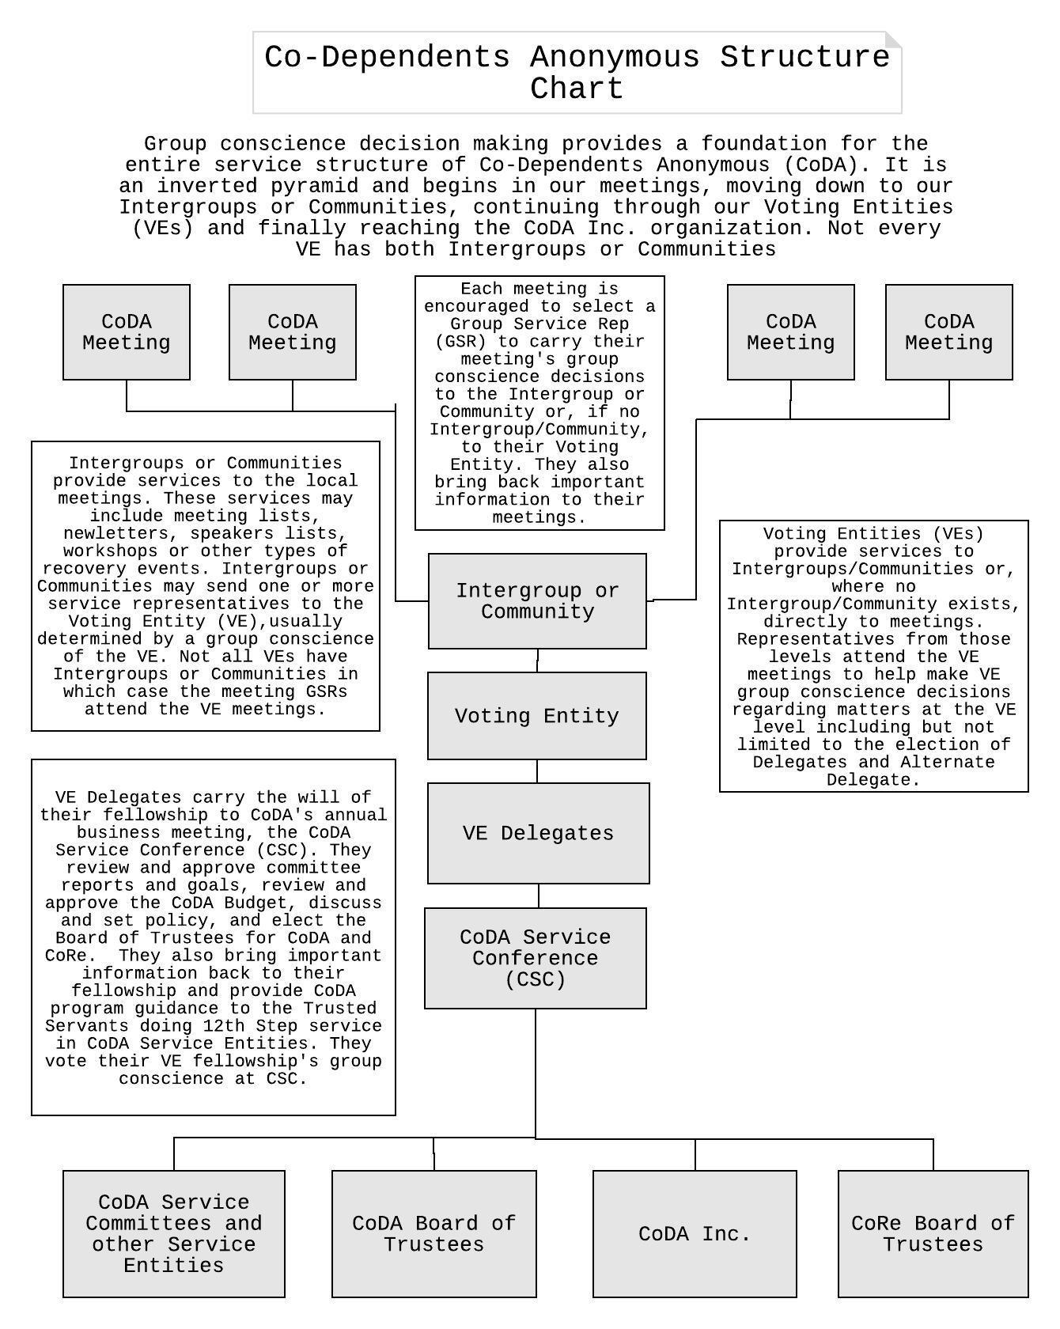

Intent, background, other pertinent information: This will provide more detail to trusted servants in World Service illustrating and clarifying the authorization process for their service work. Part 5 of the FSM, “World Level Service Details” is the place for this illustration.
Remarks:
Task Lists
The following lists of tasks of the Fellowship, including the Board of Trustees (Fellowship Role), and the Corporation (CoDA, Inc.) illustrate the chart more concretely. They were approved by the AHC in 2019 but were recognized as still needing work and so were withdrawn at CSC 2019. Despite work by an Ad-Hoc Committee work group in 2020 they are still recognized as needing further work before being presented to Conference. Members of the Ad-Hoc committee intend to continue that work on an appropriate committee in the coming year.

To meet the spiritual purpose of our Fellowship as expressed through our CoDA Service Conference (CSC) group conscience process the following tasks belong to the Fellowship including the CoDA Board of Trustees (Fellowship Role):

To meet the spiritual purpose of our Fellowship as expressed through our CoDA Service Conference (CSC) group conscience process the following tasks belong to the Fellowship:

- Maintain our Fellowship foundational principles
  - Foster spiritual growth (12 Steps)
  - Follow the spiritual principles (12 Traditions)
  - Foster (encourage) service (12 Service Concepts)
  - Mediate as needed within the Fellowship
- Carry the CoDA message of recovery
  - Outreach
  - Communicate with the public around the world
  - Support new groups
  - Develop and approve new literature
  - Maintain the content of the website
  - Translate CoDA materials
- Maintain communications within the Fellowship
  - Support Fellowship growth through face-to-face contact with other CoDA entities both in the US and International
  - Maintain an accurate and current meeting list
  - Maintain communication among all levels
  - Maintain the content of the website
- Administrative
  - Run the CoDA Service Conference (CSC)
    - Establish the agenda
    - Update and maintain the content of the motions database
  - Decide which tasks are best done by volunteer or paid members of the Fellowship and which need to be done by outside paid workers with special skills, experience and availability
- Fellowship primacy over the Corporation
  - Primacy of the Fellowship over the Corporation means that the Fellowship establishes all policies for Co-Dependents Anonymous, Inc.
  - Such policies include but are not limited to:
    - The implementation of legal compliance requirements
    - The selection criteria of Information Technology
    - The acquisition, protection, and distribution of Intellectual Property
    - The authorization of enforcement actions
    - The determination of the services the Corporations shall provide to Fellowship entities
    - The development and approval of budget

To support the CoDA Fellowship and its goals, the following tasks are assigned to the Corporation:

- Legal management
  - Execute and manage all contracts
  - Maintain custody and safeguard Intellectual Property resources including enforcement against violations when necessary
  - Maintain custody and safeguard CoDA archives
  - Maintain 501c3 status
  - Maintain legal responsibility for web content
  - Determine legal compliance
- Corporate Financial management
  - File tax returns
  - Invest prudently
  - Report at Annual Membership Meeting
  - Manage financial accounts
  - Facilitate financial disbursement process
  - Pay bills
  - Advise the Fellowship regarding the proposed budget
- Technology
  - Maintain technical/back end aspects of the website, the meeting database and other communication technologies
  - Maintain Cyber security
  - Maintain internet and phone connectivity
- Administrative management
  - Maintain mailing address
  - Hire and supervise professionals and other special workers
  - Maintain and secure physical property
  - Hold an Annual Membership Meeting
  - Validate Corporate Membership

Any tasks not covered by these lists belong to the Fellowship unless and until such time that the CSC determines they belong to the Corporation. Any modifications to these lists shall be approved by CSC.

This motion or VEI requires changes to: (please check any that apply)
____ By Laws ____ FSM P1 ____ FSM P2
____ FSM P3 ____ FSM P4 X__ FSM P5
____ Change of Responsibility
____ Other: Committee and Board action

(Data Entry Use Only)

Motion result: _______________________________________

