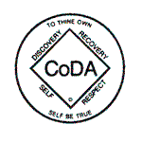

CoDA Service Conference 2016

Committee Report

Committee: Date: WCC 9/11/17

Members (list each by first name, last initial and VE):

Discussion Items:

WCC had several world online meetings in the Autumn which were well attended and received. Since then due to various family and personal issues the committee has had to regroup. We would like to say thank you to Deborah our outgoing chair for her years of dedication to WCC. As things stand we are currently meeting by internet call and are planning how to move forward. At present we have 4 member consistent members and an email list of 22. No one currently has been able to take on the chair role. But at CSC Gerry and Michael will be able to represent WCC and answer any questions.

Right now WCC does not have a chairperson, and thus we are not on 2018 Budget as a result.

Best Regards
Michael C.
WCC Volunteer

